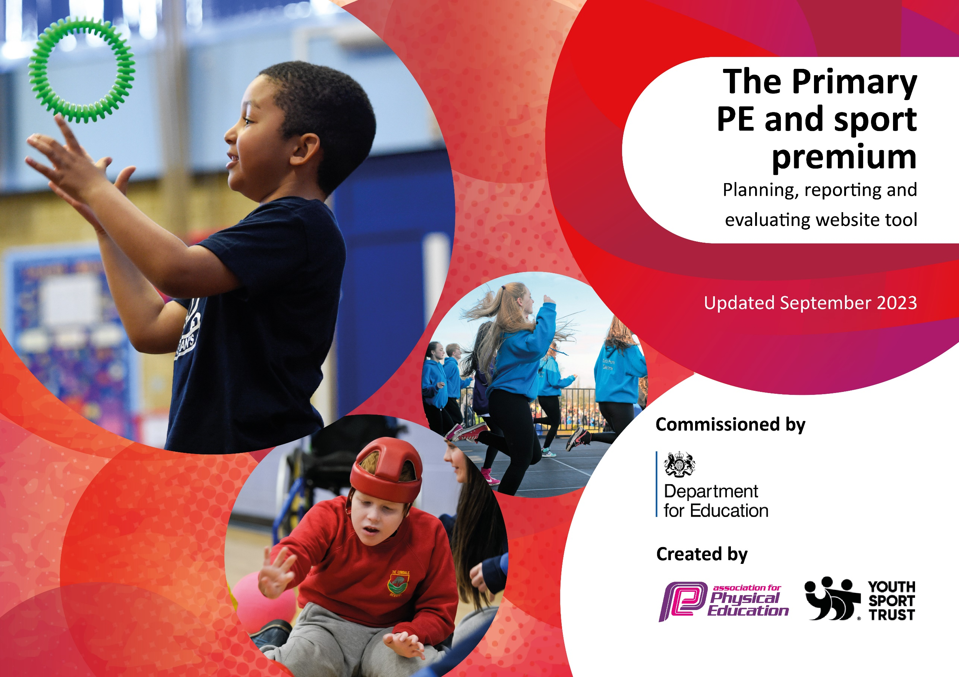

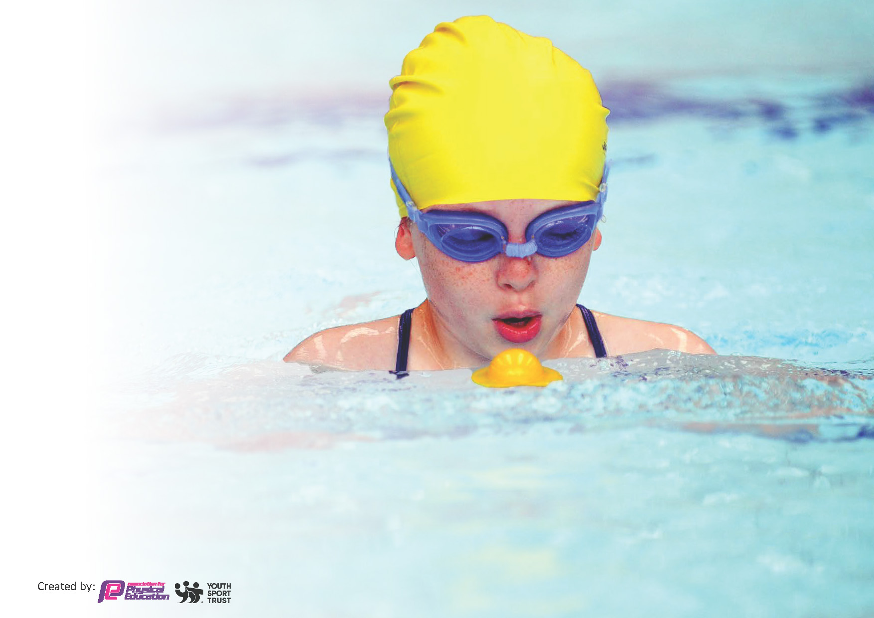
This template can be used for multiple purposes:
by:
- It enables schools to effectively plan their use of the Primary PE and sport premium
- It helps schools to meet the requirements (as set out in guidance) to publish information on their Primary PE and sport premium
- It will be an effective document to support Ofsted inspections enabling schools to evidence progress in Physical Education (PE) and evidence swimming attainment, which forms part of the PE National Curriculum. We would recommend schools consider
the Intent, Implementation and Impact of any spend, as examined within the Education Inspection Framework.

It is important that your grant is used effectively and based on school need.

Schools must use the funding to make additional and sustainable
improvements to the quality of the PE, School Sport and Physical Activity (PESSPA)
they offer. This means that you should use the Primary PE and sport premium to:

- Build capacity and capability within the school to ensure that improvements made now will benefit pupils joining the school in future years
- Develop or add to the PESSPA activities that your school already offers.

The Primary PE and sport premium should not be used to fund capital spend projects; the school’s core budget should fund these. Further detail on capital expenditure can be found in the updated Primary PE and sport premium guidance.

The Primary PE and sport premium guidance, outlines 5 key priorities that funding should be used towards. It is not

necessary that spending has to meet all the key priorities, you should select the priorities that you aim to use any funding towards.

Although completing this template is not a requirement for schools, schools are required to publish details of how they spend this funding. Schools must also outline what the impact this funding has had on pupils’ PE and sport participation and attainment and how any spending will be sustainable in the future. All funding must be spent by 31st July 2024.

The Department for Education has worked closely with the Association for Physical Education (afPE) and the Youth Sport Trust (YST) to develop this template and encourages schools to use it. This template is an effective way of meeting the reporting requirements of the Primary PE and sport premium.
Review of last year’s spend and key achievements (2022/2023)

We recommend you start by reflecting on the impact of current provision and reviewing your previous spend.

Activity/Action | Impact | Comments
Pupils will engage in physical activity every day during break time and between 12:30 and 13:00.  Equipment available to engage and motivate pupils in physical activity.  Young Leaders to play an active role in supporting younger children to engage in physical activity at break and lunch times.  Lunchtime clubs include physical activities.  Pupils in Key Stage One and Two to do PE for 2 hours per week with children in EYFS undertaking one hour of formal PE followed by a range of physical activities organized in addition to their PE lesson. Headteacher to lead PE.  Staff training for forest schools.  Increase participation in sporting events organized by NOSSP to broaden pupils experiences.  Cherwell Youth Activators working with children across the school.  Gymnastics coaching leading training sessions for teacher in Autumn Term  Tennis coach leading training sessions for teacher in Autumn Term  Complete PE Planning purchased to provide teachers with planning resources and ensure consistency and high quality of lessons taught for all year groups.  Externally provided Football club and other staff lead clubs  Sports Day with pupils competing against one another. Involve sports leaders from the Cooper school to lead different stations at Sports Day. | Children have been more engaged with physical activity during break and lunch times. They can be seen using the equipment.  Children and staff have a range of games and activities to do at lunch and during active breaks. Fitness levels of children are increased.  Children have the opportunity to develop their leadership skills.  Younger children become more active at break and lunchtimes.  Pupils in KS2 have 2 hrs timetabled each week including sessions in hall for dance and gymnastics.  Pupils engaging in forest school activities.  Increased opportunities for children develop their skills and have the chance to represent their school and are encouraged to develop their confidence and sense of worth through representing their school.  Children experience competing with other schools.  Teachers are more confident in delivery of tennis and gymnastics lessons.  Pupils have improved their skills and engagement.  Complete PE Planning provides teachers with a range of lesson plans and resources to develop the quality of PE delivery.  Pupils able to apply skills learnt to a match scenario.  All classes compete in competitive house competitions.

Key priorities and Planning
This planning template will allow schools to accurately plan their spending.

Action – what are you planning to do | Who does this action impact? | Key indicator to meet | Impacts and how sustainability will be achieved? | Cost linked to the action
Staff to lead lunchtime games during the 2023/24 academic year.  Sports Activators to run lunchtime clubs once a week during the Autumn and Spring term 2022-23.  To develop the Young Leader role more in 2022/23 so they are more confident in leading sessions without as much adult support. | Lunchtime supervisors / teaching staff, coaches - as they need to lead the activity  pupils – as they will take part | Key indicator 2: increasing engagement of all pupils in regular physical activity and sport  Key indicator 3: raising the profile of PE and sport across the school, to support whole school improvement  Key indicator 4: offer a broader and more equal experience of a range of sports and physical activities to all pupils | More pupils meeting their daily physical activity goal, more pupils encouraged to take part in PE and Sport Activities. | £1000 costs for Youth Activators  £1678.34  Playground Equipment maintenance  Equipment £40.62
To develop the PE provision to ensure pupils experience a wide range of PE activities. – through staff CPD in lessons  To train additional staff to lead swimming during the 2023-24 academic year.  Fully embedding the complete PE scheme across the school. To include the assessment elements of the scheme to track progress.  To continue to employ the services of Stuart Wells to support in the teaching of PE during the 2023-24. | teaching staff confidence in delivering PE  pupils – as they will take part | Key indicator 1: increasing all staff’s confidence, knowledge and skills in teaching PE and sport  Key indicator 2: increasing engagement of all pupils in regular physical activity and sport  Key indicator 4: offer a broader and more equal experience of a range of sports and physical activities to all pupils | Greater staff knowledge to ensure high quality swim training.  Teachers more confident to deliver effective PE supporting pupils to undertake extra activities inside and outside of school | Gymnastics coach £1000  Tennis coach  £850  Swim training - £360  Complete PE - £150  Stuart Wells – 4900  ECT PE Day - £300
To raise the profile of inter-house sporting competitions.  To further engage with opportunities for sporting competitions outside school.  To develop a sports leaders with a focus on developing sporting events within school.  To develop and introduce more inter-school competitions in 2023-24 competing in a range of different sports through the development of sports council | pupils – as they will take part  NOSSP support  Sports Leaders | Key indicator 2: increasing engagement of all pupils in regular physical activity and sport  Key indicator 3: raising the profile of PE and sport across the school, to support whole school improvement  Key indicator 4: offer a broader and more equal experience of a range of sports and physical activities to all pupils  Key indicator 5: increase participation in competitive sport | More pupils meeting their daily physical activity goal, more pupils encouraged to take part in PE and Sport Activities. | School kit of pupils attending events  £800  NOSSP - £2200
To continue to develop the role of the Eco-council developing healthy lifestyles to include- walk to school week. | Eco council  All pupils  Eco council leaders | Key indicator 2: increasing engagement of all pupils in regular physical activity and sport  Key indicator 3: raising the profile of PE and sport across the school, to support whole school improvement | Pupils have a deeper understanding of health eating and healthy lifestyles.

Key achievements 2023-2024
This template will be completed at the end of the academic year and will showcase the key achievements schools have made with their Primary PE and sport premium spending.

Activity/Action | Impact | Comments
staff to lead in lunchtime games during the 2023/24 academic year.  To use Sports Activators to run lunchtime clubs once a week during the Autumn and Spring term 2022-23.  To train additional staff to lead swimming during the 2023-24 academic year.  To develop a clear cycle of forest school teaching to ensure all classes engage in forest school sessions and resourcing for these sessions.  Sports day and attending sporting competitions  Children will be inspired to do their best and learn new skills and disciplines.  To develop a sports leaders with a focus on developing sporting events within school.  To continue to develop the role of the Eco-council developing healthy lifestyles to include- walk to school week.  To develop coaching of other skills/sports eg cricket.  To continue to employ the services of Stuart Wells to support in the teaching of PE during the 2023-24. | More children engaged in an active lifestyle during break times. Engaging children from FSU to Year 6.  Pupils awareness of wellbeing increased as well as active lifestyle choices.  3 Members of staff now trained, meaning no sessions will be missed due to absence/ more groups of children can be taught.  All children engaging in Forest school multiple times a year, well-being of all children improved  Children have had the opportunity to attend a wide range of sporting competitions/activities to develop confidence and skills.  Sports leaders raising the profile of active life styles through workshops, events and lunchtime clubs.  Increased awareness of healthy lifestyles including healthy lunch boxes.  Increased staff confidence in delivering cricket/gymnastics sessions. | Teaching assistants leading has been hard as they are also supervising, instead we have introduced clubs led by children which have been very successful as well as teacher led clubs

Swimming Data
Meeting National Curriculum requirements for swimming and water safety.
Priority should always be given to ensuring that pupils can perform safe self-rescue even if they do not fully meet the first two requirements of the National Curriculum programme of study

Question | Stats: | Further context  Relative to local challenges
What percentage of your current Year 6 cohort can swim competently, confidently and proficiently over a distance of at least 25 metres? | 88.9%
What percentage of your current Year 6 cohort can use a range of strokes effectively [for example, front crawl, backstroke, and breaststroke]? | 77.8%

What percentage of your current Year 6 cohort are able to perform safe self-rescue in different water-based situations? | 77.8%
If your schools swimming data is below national expectation, you can choose to use the Primary PE and sport premium to provide additional top-up sessions for those pupils that did not meet National Curriculum  requirements after the completion of core lessons. Have you done this? | No
Have you provided CPD to improve the knowledge and confidence of staff to be able to teach swimming and water safety? | Yes | Swim training for 2 members of staff took place this academic year. One as a refresher.

Signed off by:

Head Teacher: | Nadia Gosling
Subject Leader or the individual responsible for the Primary PE and sport premium: | Nadia Gosling
Governor: | Graham Mogridge
Date: | 08/07/2024

